PROP 68 - RIVER PARKWAYS-SIGN GUIDELINES

Types of Signs

- Construction - A sign acknowledging the funding source is required during construction.

- Post Completion - All grantees are required to post a sign at the project site upon completion of the project. The sign must be available for the final inspection of the project and be in place for a minimum of four (4) years from date of project completion. There is no minimum or maximum size other than the minimum size for the logo as long as the sign contains the required wording.

If appropriate, the same sign can be used during construction and completion.

Language for Signs
Project Title/Description
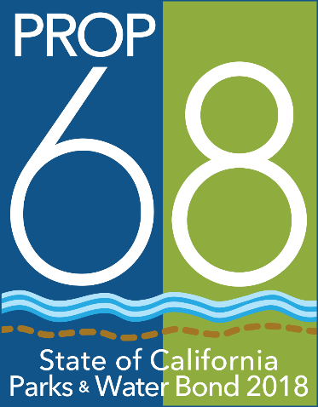
Another project funded
Through the California
Natural Resources
Agency to improve
River Parkways

GAVIN NEWSOM,
GOVERNOR
Wade Crowfoot, Secretary
for Natural Resources
All signs will contain the following minimum language as seen on the side panel to the right. The name of the director of the local public agency or other governing body may also be added. The sign may also include the names (and/or logos) of other partners, organizations, individuals and elected representatives.

Logo
All signs must contain the logo for the Parks and Water Bond Act. The logo is available at https://resources.ca.gov/grants/Grant-Program-Resources. The logo must be mounted in an area to maximize visibility and durability. Each edge of the logo itself must be a minimum of 24” X 24”. Exceptions may be approved when appropriate at the discretion of the State.

Sign Construction
All materials used shall be durable and resistant to the elements and graffiti. The California Department of Parks and Recreation and California Department of Transportation standards can be used as a guide for gauge of metal, quality of paints used, mounting specifications, etc.

Sign Cost
The cost of the sign(s) is an eligible project cost. Permanent signage is encouraged.

Appropriateness of Signs
For projects where the required sign may be out of place or where affected by local sign ordinances, the Grants Administrator in consultation with the grantee may authorize a sign that is appropriate to the project in question.

Signs on State Highways
Signs placed within the state highway right-of-way may require a Caltrans encroachment permit. Contact the local Caltrans District Office early in the planning phases for more information. For locations, visit http://www.dot.ca.gov/contactus.html.

State Approval
The grantee shall submit proposed locations, size, number of signs and language for review prior to ordering signs. Final funds for development projects will not be reimbursed until signage has been approved and installed.

