APPENDIX K – SIGNAGE AND RECOGNITION GUIDELINES
Types of Signs

- Construction - A sign acknowledging the funding source is required during construction.

- Post Construction Completion – A funding acknowledgement sign must be installed before the final project inspection and remain in place for at least four (4) years from the date of project completion. The size of the sign is not prescribed; however, the funding source logo must comply with minimum size requirements and all required funding language.

If appropriate, the same sign can be used during construction and completion.

- Vehicle Acquisition Completion - Funding acknowledgement recognition must be installed on each vehicle before the final project inspection and remain in place for at least four (4) years from the date of project completion. The size of the recognition on the vehicle is not prescribed; however, the funding source logo must comply with minimum size requirements and all required funding language.

Project Title/Description

Another community access project through the Natural Resources Agency
to improve youth access to natural and cultural resources
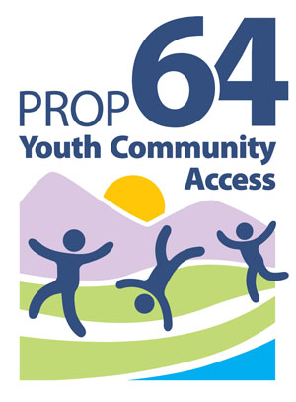

GAVIN NEWSOM, GOVERNOR
Wade Crowfoot, Secretary for Natural Resources

Sign Language
All signs must contain the language shown to the right. The name of the director of the local agency or other governing body may be added, as well as the names (and/or logos) of othe partners, organizations, individuals, and elected representatives.

Logo
All signs must contain a Youth Community Access Grant Program logo (see the box to the right). The program logo is available at https://resources.ca.gov/grants/Grant-Program-Resources under Logo Artwork. The logo must be mounted in an area maximizing visibility and durability. The logo must measure a minimum of 12 inches in height. When appropriate, exceptions may be approved at the State’s discretion.

Sign Construction
All materials used shall be durable and resistant to the elements and graffiti. The California Department of Parks and Recreation and California Department of Transportation standards can be used as a guide for gauge of metal, quality of paints, mounting specifications, etc.

Sign Cost
The cost of the sign(s) is an eligible project cost. Permanent signage is encouraged.

Appropriateness of Signs
For projects where the required sign may be out of place or affected by local sign ordinance, the State may authorize a sign that is more appropriate to the project.

Signs on State Highways
Signs placed within the state highway right-of-way may require a Caltrans encroachment permit. Contact your local Caltrans District Office early in the planning process for more information. For District Office locations, see https://dot.ca.gov/caltrans-near-me.

State Approval
Grantee shall submit the proposed number, location(s), size, and language of sign for review prior to ordering signs. Final funds for projects will not be reimbursed until signage has been approved and installed.

Program Recognition
The Grantee shall use the Youth Community Access Grant Program logo on any project announcements, social media, website, marketing materials, and news releases.

