Blue Ribbon Committee for the Rehabilitation of Clear Lake
Meeting #22
December 13, 2022, 10am-1pm*
In person: Clearlake Senior Center Auxiliary Room, 3245 Bowers Ave, Clearlake, CA
Remote participation: See Page 2 for Details

AGENDA
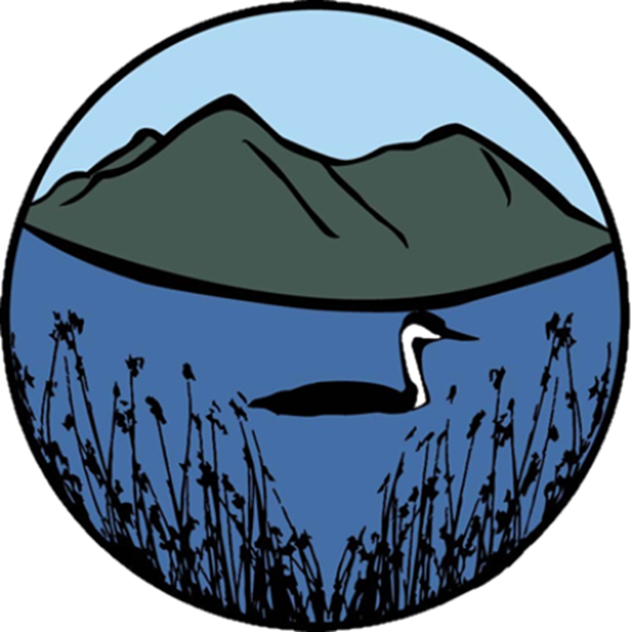
Meeting Agenda

- Welcome and Introductions
Eric Sklar, Committee Chair
Sam Magill, California State University, Sacramento

- Items for Committee Approval:
- September 8, 2022 Meeting Summary
All Committee Participants

- Request Approval of Committee Vision and Proposal Requirements
All Committee Participants

- Request Approval of 2022 Annual Report
All Committee Participants

- Request Approval of Prop 68 Funding Options for 2022 Restoration Projects
All Committee Participants

- Public Comment
Interested Members of the Public

- MEETING ADJOURNS

REMOTE MEETING INFORMATION:

To join the meeting remotely, please click on the link below.

Zoom Link: https://csus.zoom.us/j/86016359747

Meeting ID: 860 1635 9747

One tap mobile
+16699006833,,86016359747# US (San Jose)
+16694449171,,86016359747# US

Dial by your location
+1 669 900 6833 US (San Jose)
+1 669 444 9171 US
+1 253 215 8782 US (Tacoma)
+1 346 248 7799 US (Houston)
+1 719 359 4580 US
+1 253 205 0468 US
+1 305 224 1968 US
+1 309 205 3325 US
+1 312 626 6799 US (Chicago)
+1 360 209 5623 US
+1 386 347 5053 US
+1 507 473 4847 US
+1 564 217 2000 US
+1 646 876 9923 US (New York)
+1 646 931 3860 US
+1 689 278 1000 US
+1 301 715 8592 US (Washington DC)

Meeting ID: 860 1635 9747

Find your local number: https://csus.zoom.us/u/kpyBg14bV

